Lab 7:
1.WAP to implement auto correlation test.
Source Code:
#include <stdio.h>
#include <stdlib.h>
int main() {
float random_numbers[50] = {0.12, 0.23, 0.34, 0.45, 0.56, 0.67, 0.78, 0.89, 0.91, 0.99, 0.05, 0.15, 0.25, 0.35, 0.46, 0.57, 0.68, 0.79, 0.81, 0.95, 0.02, 0.14, 0.24, 0.36, 0.47, 0.58, 0.69, 0.74, 0.84, 0.94, 0.04, 0.13, 0.22, 0.32, 0.42, 0.52, 0.62, 0.72, 0.82, 0.92, 0.03, 0.11, 0.21, 0.31, 0.41, 0.51, 0.61, 0.71, 0.83, 0.93};
int i, d = 3; // d is lag value
float mean = 0, numerator = 0, denominator = 0, auto_corr;
for (i = 0; i < 50; i++) {
mean += random_numbers[i];
}
mean /= 50;
for (i = 0; i < 50 - d; i++) {
numerator += (random_numbers[i] - mean) * (random_numbers[i + d] - mean);
}
for (i = 0; i < 50; i++) {
denominator += (random_numbers[i] - mean) * (random_numbers[i] - mean);
}
auto_corr = numerator / denominator;

printf("Auto-Correlation Coefficient: %f\n", auto_corr);
return 0;
}
Output:
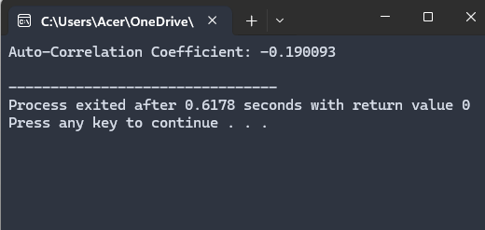

2. WAP to implement Poker test.
Source Code:
#include <stdio.h>
#include <stdlib.h>

int main() {
int random_numbers[50] = {123, 234, 345, 456, 567, 678, 789, 890, 901, 999,
105, 215, 325, 435, 546, 657, 768, 879, 981, 995,
202, 314, 424, 536, 647, 758, 869, 974, 884, 994,
104, 213, 322, 432, 542, 652, 762, 872, 982, 992,
302, 411, 521, 631, 741, 851, 961, 771, 881, 991};
int i, j, digit_count[10], pair = 0, triple = 0, no_match = 0;

for (i = 0; i < 50; i++) {
for (j = 0; j < 10; j++) {
digit_count[j] = 0;
}

int num = random_numbers[i];
while (num > 0) {
digit_count[num % 10]++;
num /= 10;
}

int has_pair = 0, has_triple = 0;
for (j = 0; j < 10; j++) {
if (digit_count[j] == 2) has_pair = 1;
if (digit_count[j] == 3) has_triple = 1;
}

if (has_triple) triple++;
else if (has_pair) pair++;
else no_match++;
}

printf("Poker Test Results:\n");
printf("Pairs: %d\n", pair);
printf("Triples: %d\n", triple);
printf("No Matches: %d\n", no_match);

return 0;
}
Output:
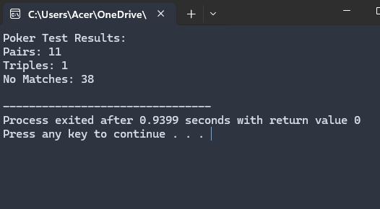

3. WAP to implement chi-square test.
Source Code:
#include <stdio.h>
#include <stdlib.h>
#include <math.h>
int main() {
int observed_frequencies[10] = {0};
float expected_frequency = 5.0; // For uniform distribution with 50 numbers across 10 bins
int i;
float chi_square = 0;
int random_numbers[50] = {12, 23, 34, 45, 56, 67, 78, 89, 91, 99,
5, 15, 25, 35, 46, 57, 68, 79, 81, 95,
2, 14, 24, 36, 47, 58, 69, 74, 84, 94,
4, 13, 22, 32, 42, 52, 62, 72, 82, 92,
3, 11, 21, 31, 41, 51, 61, 71, 83, 93};
for (i = 0; i < 50; i++) {
observed_frequencies[random_numbers[i] / 10]++;
}
for (i = 0; i < 10; i++) {
chi_square += pow(observed_frequencies[i] - expected_frequency, 2) / expected_frequency;
}
printf("Chi-Square Test Statistic: %f\n", chi_square);
return 0;
}
Output:
